What is AngularJs ?

* AngularJS is a java script framework
* It can be added to html script using <script> tag

<script src="https://ajax.googleapis.com/ajax/libs/angularjs/1.6.9/angular.min.js"></script>

* Used to manipulate DOM

ng – app

<!DOCTYPE html>

<html>

<script src="https://ajax.googleapis.com/ajax/libs/angularjs/1.6.9/angular.min.js"></script>

<body>

<div ng-app="">

<p>Input something in the input box:</p>

<p>Name: <input type="text" ng-model="name"></p>

<p ng-bind="name"></p>

</div>

</body>

</html>

Understanding angularjs directives:

Ng-app

Ng-model

Ng-bind

Install angular cli:

Install nodejs 20

Terminal should be in command prompt mode. / not powershell

npm install -g @angular/cli

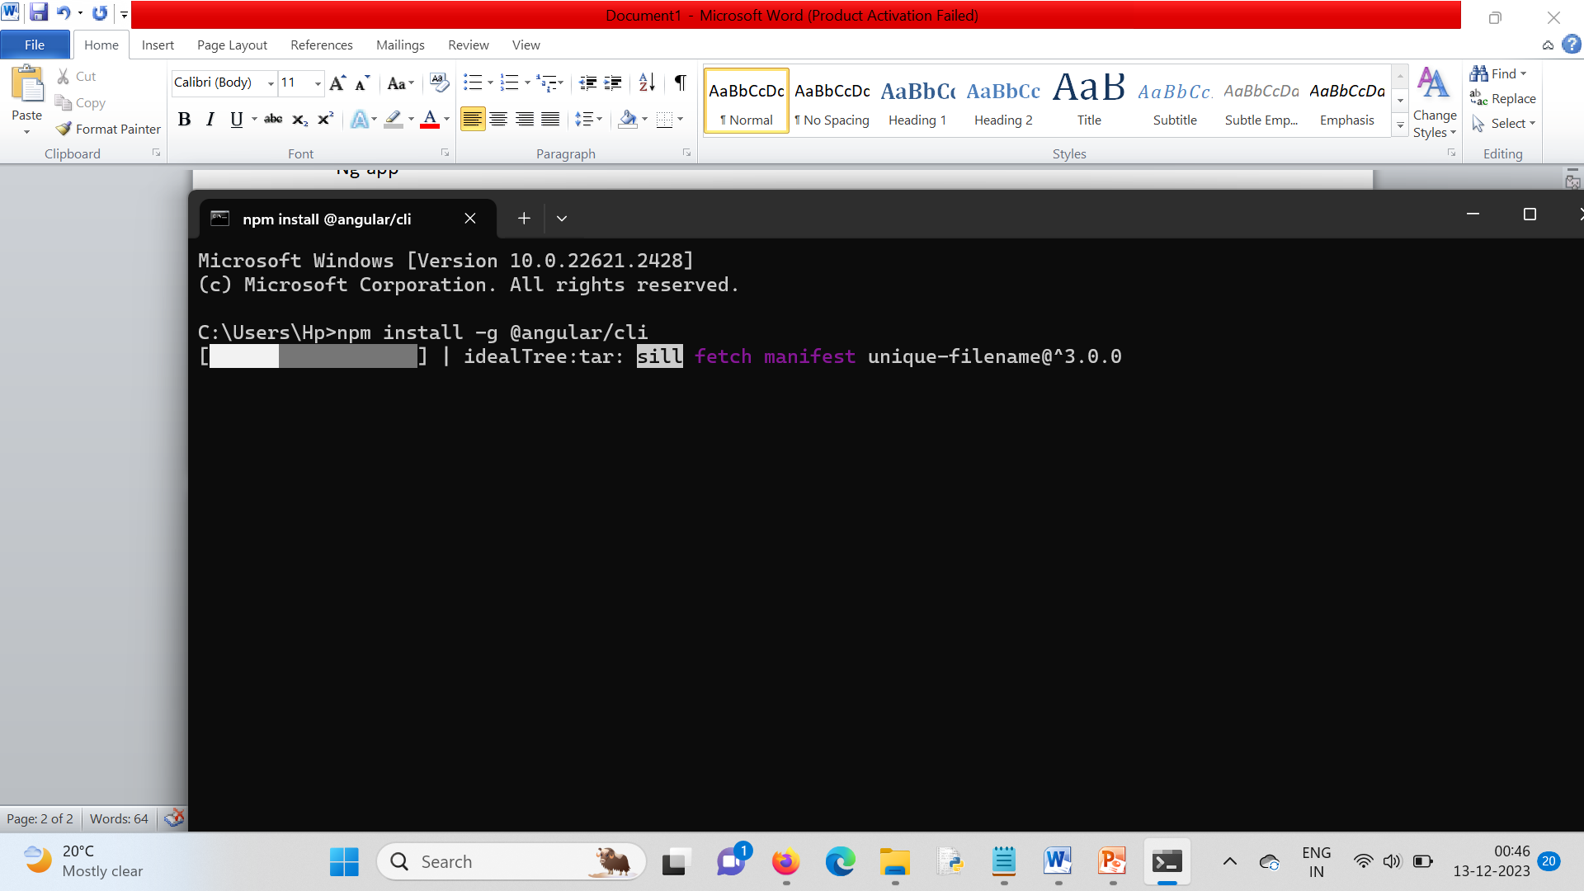

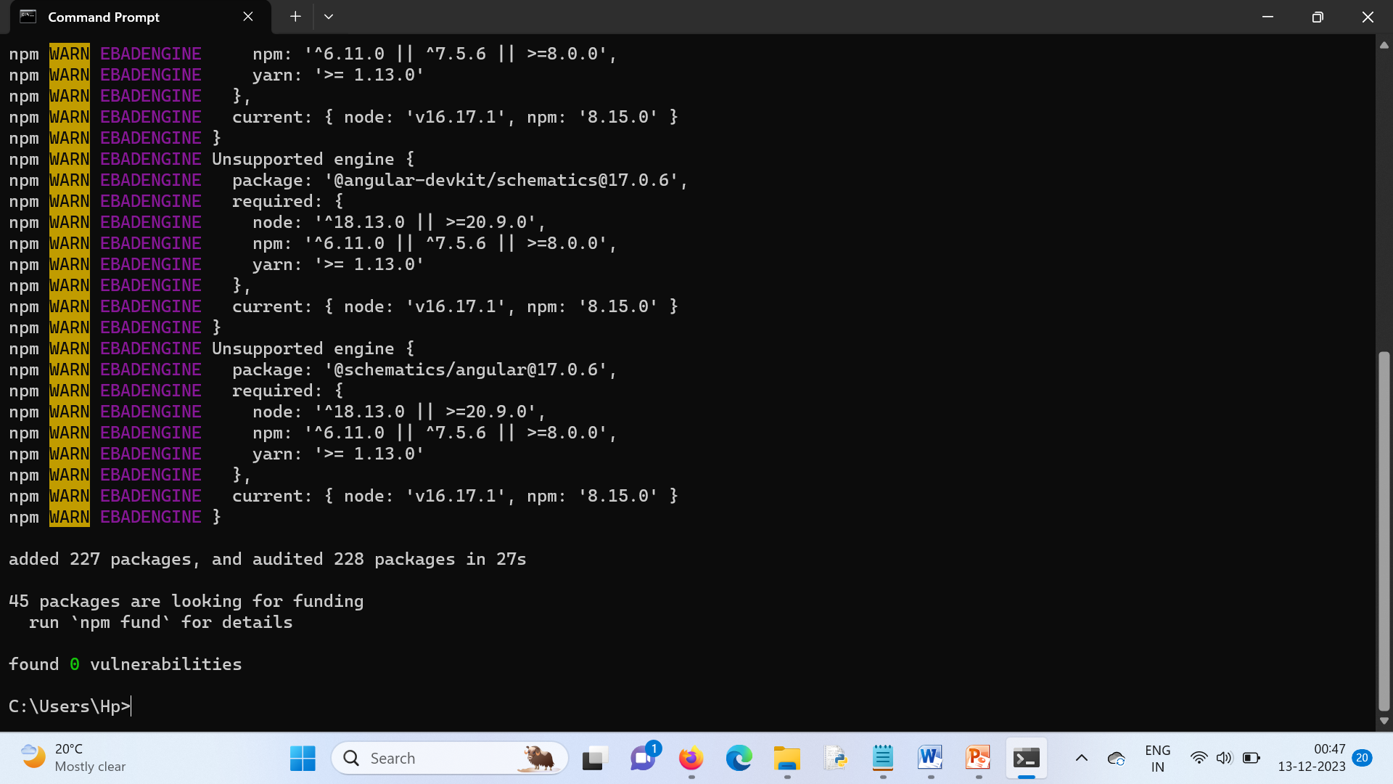

Npm : node package manager

Step-1>

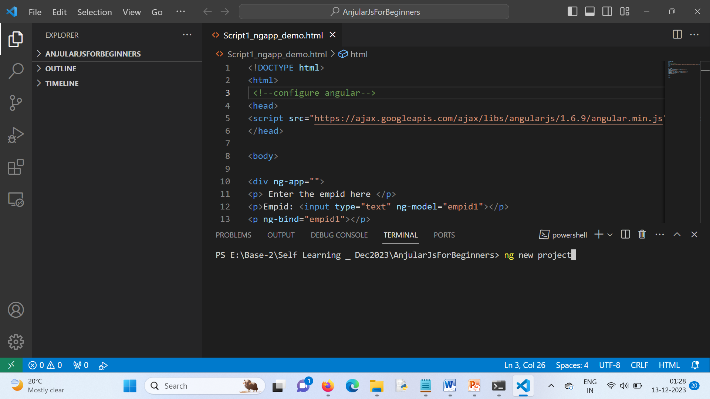

Step-2> 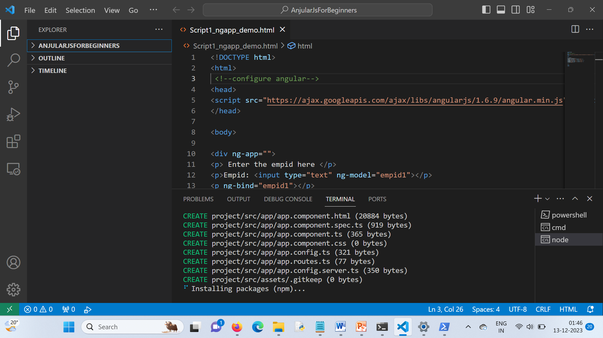

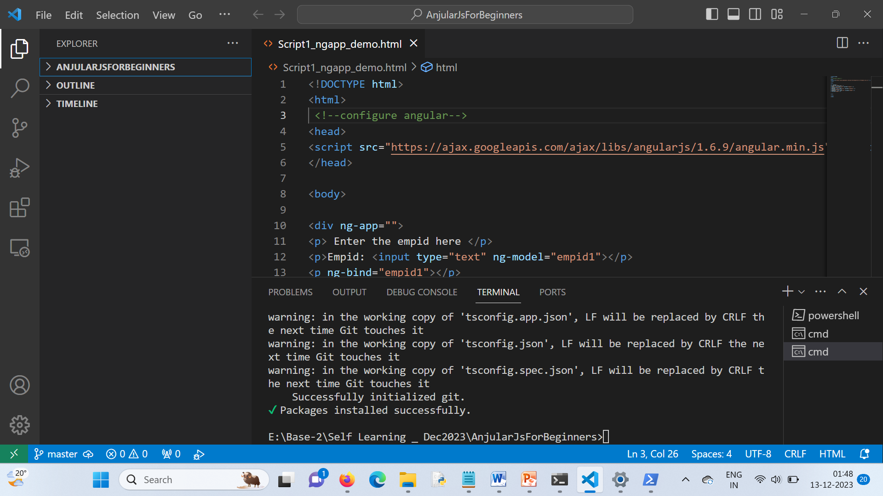

Enter into project folder :

Cd project

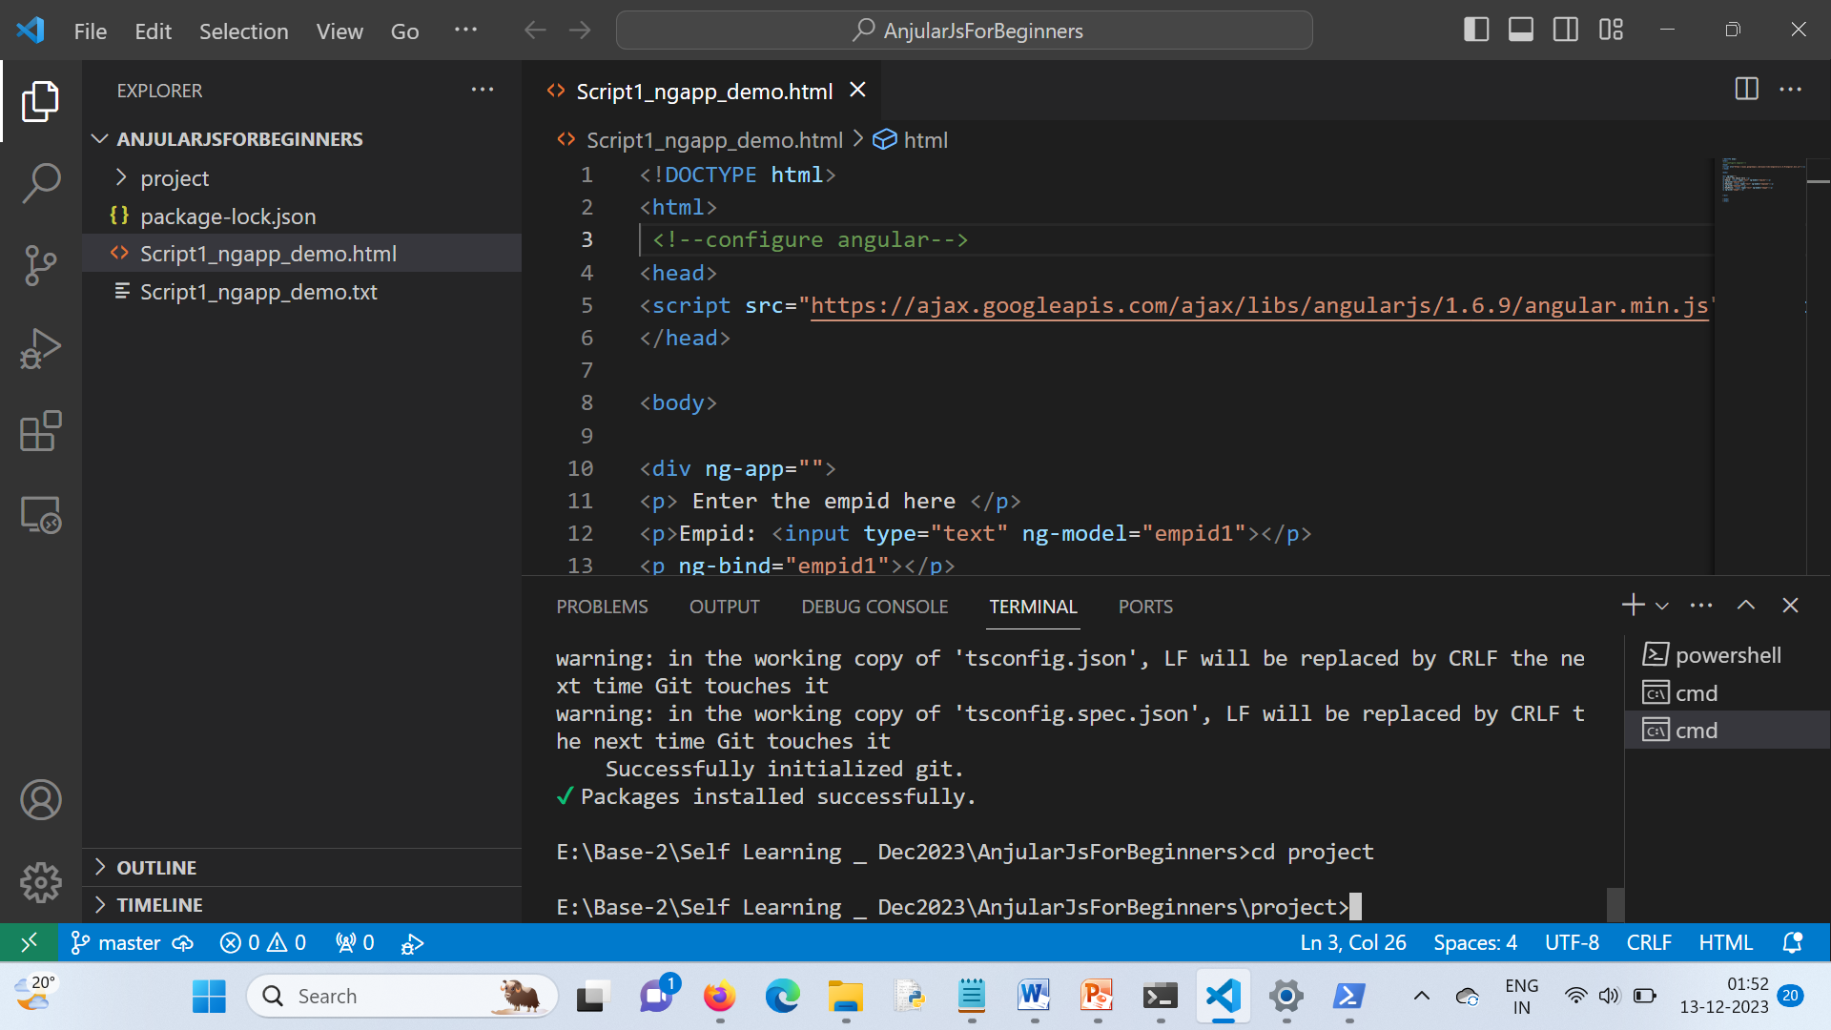

To open the project from browser:

## 

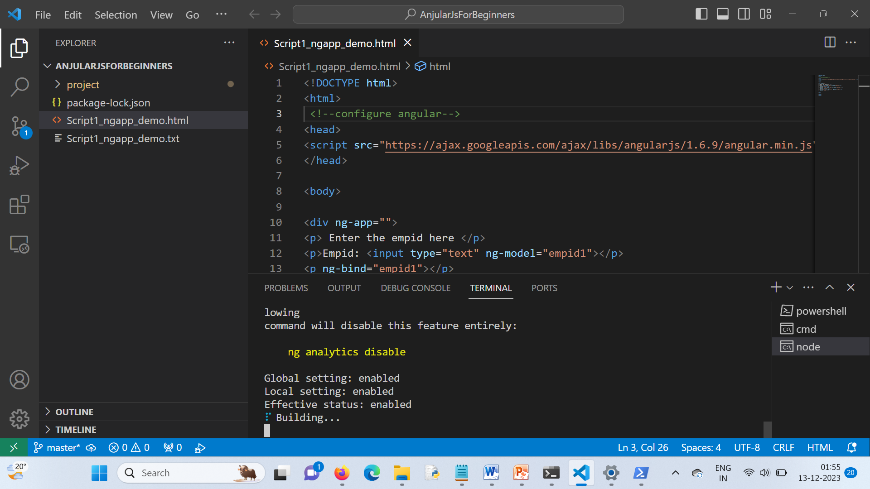

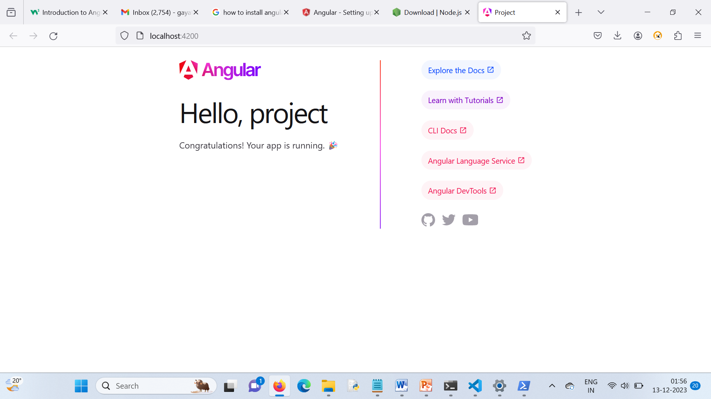

Root componenet – index.html